1. Execute and display the results for the following commands in Kali Linux Operating Systems:
rm command
users command
tree command

AIM:
To execute and demonstrate the rm, users, and tree commands in the Kali Linux operating system and observe their outputs.
DESCRIPTION:
1. rm Command — Description
The rm (remove) command is used to delete files and directories from the Linux operating system.
Example:
rm test.txt
This command deletes the test.txt file.
Output:
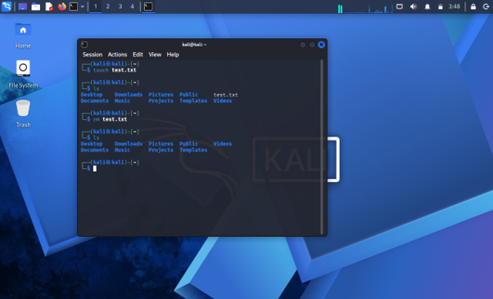
2. users Command — Description
The users command is used to display the usernames of users who are currently logged into the Linux system.
Example:
users
It displays the currently logged-in username.
Output:
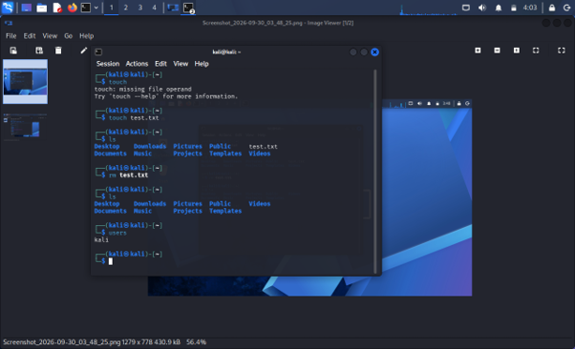
3. tree Command — Description
The tree command is used to display files and directories in a hierarchical tree-like structure.
Example:
tree
It shows the folders and files in a tree format.

Output:
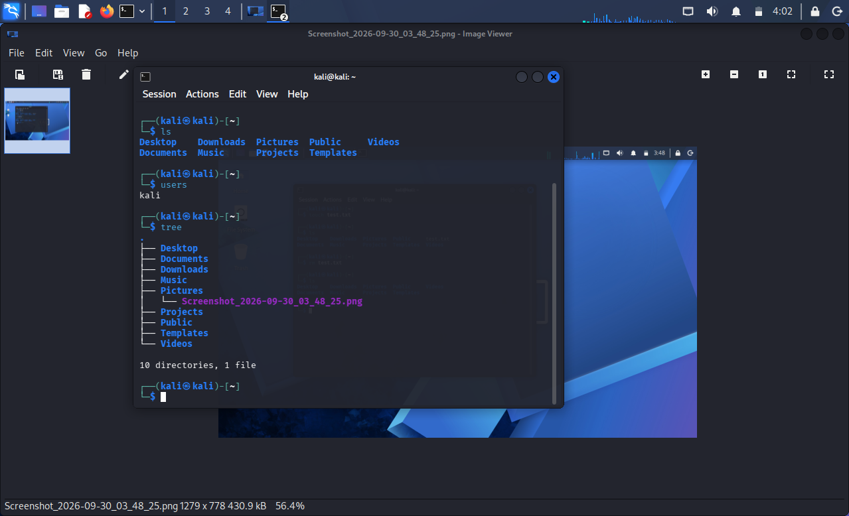

RESULTS:
The rm, users, and tree commands were successfully executed in the Kali Linux operating system, and their respective outputs were observed.

